Ryan Ellis
COSC 320 --- 001 Lab 1 2/5/2025

Lab report: In this lab, an algorithm for a double-ended selection sort was written to see if the timing complexity would be similar or better than the normal selection sorting algorithm. This lab took me approximately an hour to complete, cumulatively.

Pre-lab: Review of the design, implementation, and complexity of each of the following algorithms:
- Bubble sort
- Selection sort
- Insertion sort
- Merge sort
- Quicksort
- Radix sort

Lab 1.1

Exercise 1:

Source Code:

Header file
#ifndef DESELSORT_H
#define DESELSORT_H

#include <utility>
#include <vector>
#include <iostream>

using namespace std;

template <class T>
void deSelsort( T arr[], int size);
template <class T>
void printArray(T arr[], int size);
template <class T>
void selectionSort(T arr[], int size);

#endif
template <class T>
void printArray(T arr[], int size ){ //function to print array
for(int i = 0; i < size; i++){
cout<< arr[i]<< " ";
}
cout<<endl;
}
template <class T>
void selectionSort(T arr[], int size ){ //regular selection sort
int minIndex, minValue;

for(int start = 0; start < (size - 1); start++){
minIndex = start;
minValue = arr[start];
for(int index = start +1; index < size; index++){
if (arr[index] <minValue){ //finds min value and swaps index
minValue = arr[index];
minIndex = index;
}
}

swap(arr[minIndex], arr[start]); //swap min value at index

cout<< "Pass "<< start + 1<< ": "; //print out array at pass
printArray(arr, size );
}
}

template <class T>
void deSelsort(T arr[], int size){ //double ended selection sort

int minIndex, maxIndex; // min and max index, right side set at end of array
int right = size -1;

for(int left = 0; left < right; left++, right--){ //for loop to end once left and right meet, increase left, decrease right

minIndex = left;
maxIndex = right; //set min to left, max to right

for(int index = left; index <= right; index++){ // nested for loop with index set to left, less than or equal to right

if( arr[index] < arr[minIndex]){ //conditional statements to set index to min, max dependent on greater/less than
minIndex = index;
}
if(arr[index] > arr[maxIndex]){
maxIndex = index;
}
}

swap(arr[left], arr[minIndex]); //swap values

if(maxIndex == left){
maxIndex = minIndex; //set max index to min if it was at left before swap
}

swap(arr[right], arr[maxIndex]);

cout<< "Pass " << left + 1<< ": "; //print array at pass
printArray(arr,size );

}

}

Implementation (main program) :

#include "deSelsort.h"
#include <iostream>

using namespace std;

void div(); //prototype

int main(){

int array[8] = {13, 5, 2, 25, 47, 17, 8 , 21}; //array declaration

for(int i = 0; i < 8; i++) //print original array
cout<< array[i] << " ";
div();
cout<< "Selection Sort : "<<endl; //regular selection sort function call
selectionSort(array, 8 );
div();
int array2[8] = {13, 5, 2, 25, 47, 17, 8 , 21};

cout<< "Double Selection Sort : "<<endl; //double ended selection sort function call
deSelsort(array2, 8);
div();

return 0;

}

void div(){
cout<<endl; //function to print line
}

Terminal Output:
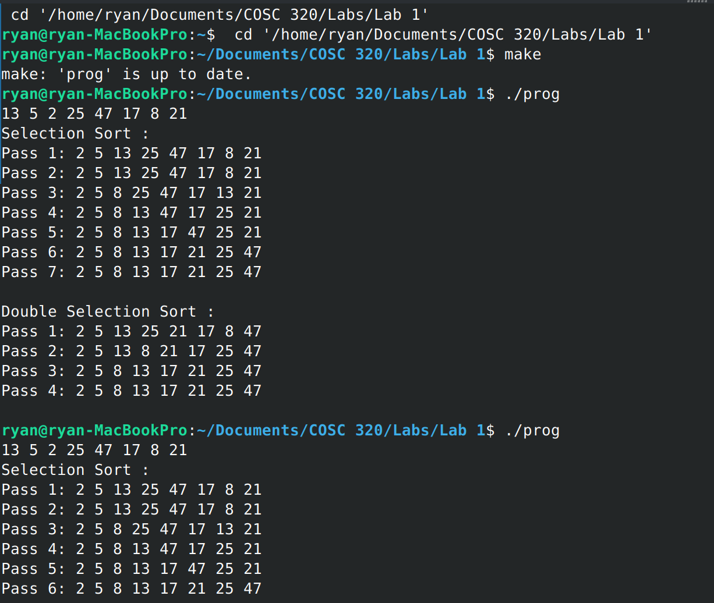
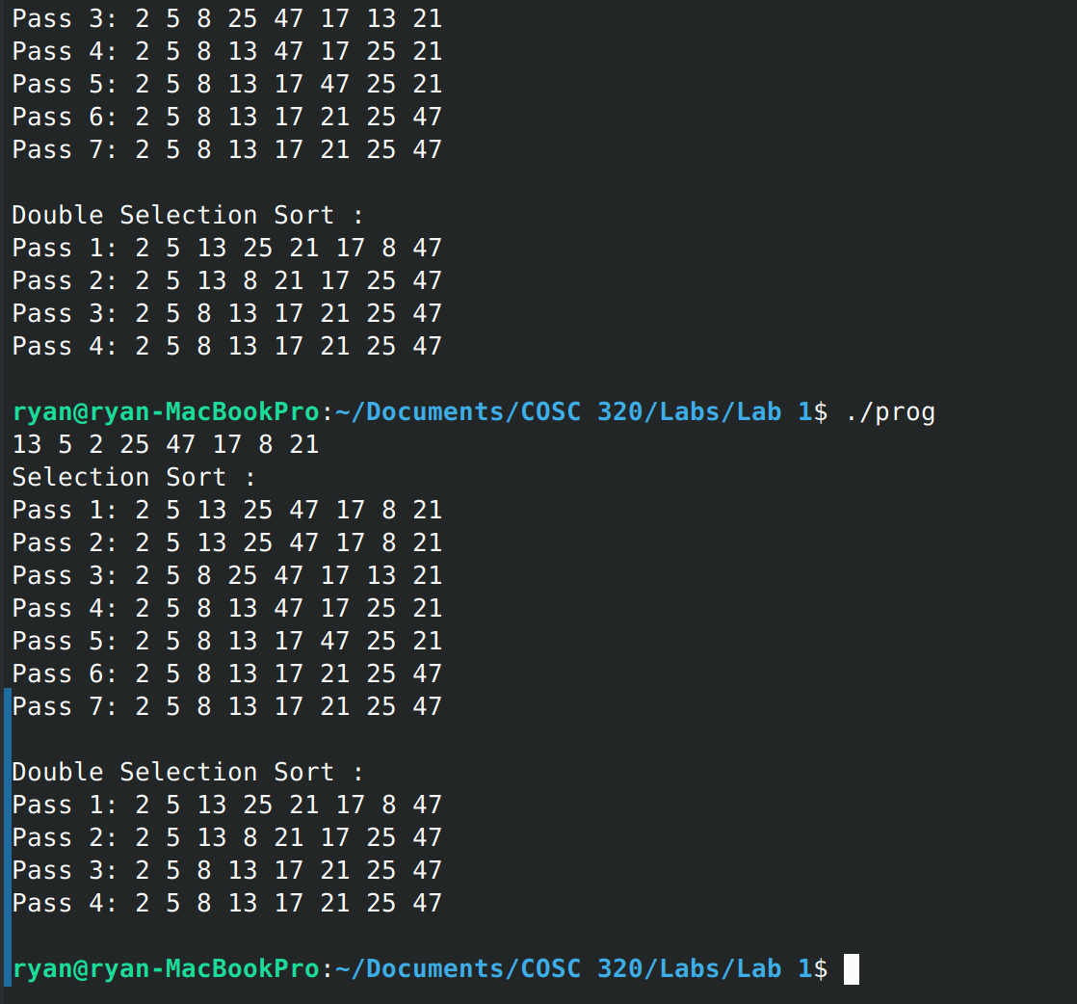

[answers for exercise]

……
Lab Questions:
1) When does the sorting algorithm end?
The algorithm ends when both the indices for the inner and outer for loops reach the middle and all the comparisons have been made for each element within the array.

2) What is the time complexity of the double-ended selection sort? Is it better than the selection sort?
The timing complexity for the double-ended selection sort is still the same as the normal selection sorting algorithm (O(n²)), as it uses the same structure of a nested for loop, so the comparisons are still being used in the same way, however with the double-ended selection sort we reach the end of a sorted array with less passes through the loops.

